Operations/Work/Job Activity covered by this assessment: Sealant Application
Required Personal Protective Equipment (PPE) :

Safety glasses must be worn at times. |   Long and loose hair must be contained.
  Appropriate footwear with substantial uppers must be worn. |   Close fitting/protective clothing to cover arms and legs must be worn.
Respiratory protection devices required. |   Oil free leather gloves and spats must be worn.

Hearing protection must be used when using this machine.

- Clean the surface thoroughly to remove dust.
- Ensure thermal coating is fully cured and surface is clean and dry.
- Apply scotch brite brush lightly on the coated surface to remove high points.
- Ensure the sealant solution is properly mixed and loaded into the hopper.
- Adjust air pressure within the range of 20 - 40 PSI.
- Set the spray gun at a distance of 6 - 8 inches from the work surface.
- Maintain a spray angle of approximately 90° to the surface.
- Set the nozzle or air cap as per the surface type:
- Vertical for cylindrical surfaces [Fig.1a]
- Horizontal for rectangular surfaces [Fig.2a]
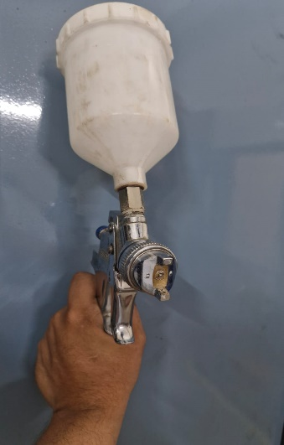

Fig.1a

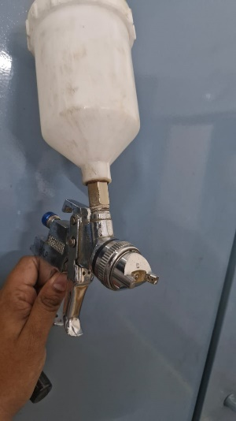

Fig.2a

Check nozzle position (Horizontal)

- Perform a test spray on paper and confirm that the spray pattern is uniform without dripping.
- Adjust screw to get proper spray pattern.
- Begin sealant application within 30 minutes of preparing the solution.
- Apply the sealant evenly, ensuring full coverage of the required area.
- Cure for 8-12hours without touching the coated surface.

Precautions :
- Ensure the air pressure is stable during spraying.
- Avoid excessive build-up of sealant in one area.
- Clean spray gun thoroughly after use to prevent clogging.
- Handle air equipment carefully to avoid accidents.
- Make sure the Air in dry and no moisture.

Check nozzle position (Vertical)

